
Stochastic Processes
Professor: Dr. Safari

Mehrnaz Yazdani, 610301201
Saba Naji, 610301190
Part 1:
- The Standardized Precipitation Index (SPI) is used to indicate drought or wet conditions. If the SPI is negative, it indicates drought conditions, and is represented by 0. If the SPI is positive, it indicates wet conditions, and is represented by 1.

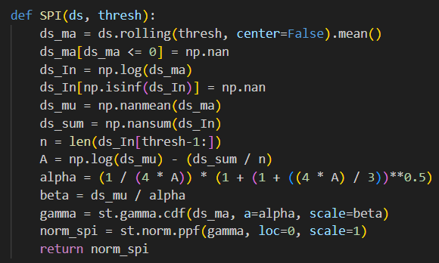
This function SPI calculates the Standardized Precipitation Index (SPI) for a series of precipitation data.
Moving Average: First, it computes the moving average of precipitation data using a window size specified by thresh.
Handling Invalid Values: Negative values are set to NaN, and the natural logarithm of the moving average is taken.
Statistical Calculations: Parameters for the gamma distribution (α and β) are calculated, and the gamma cumulative distribution function is applied to the moving average data.
Normalization: Finally, a standard normal distribution is applied to the gamma distribution to obtain the SPI.
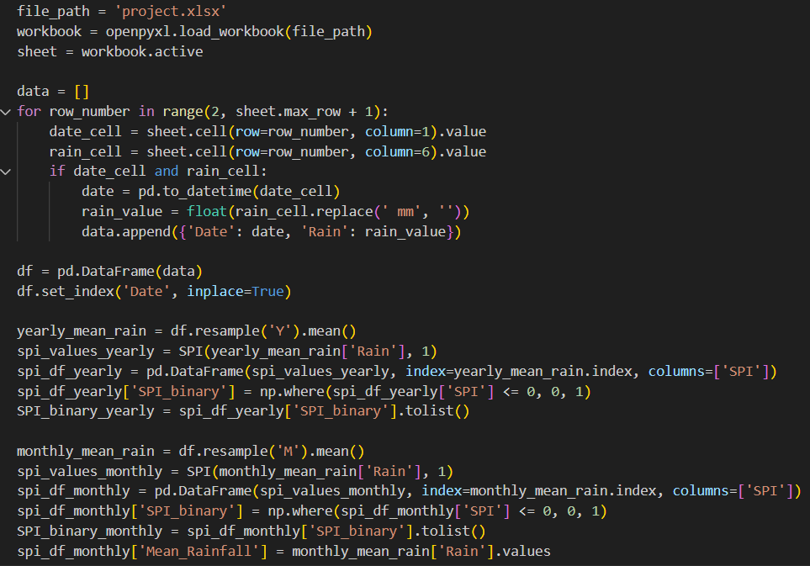
Load Data: It loads an Excel file named 'project.xlsx' using openpyxl and selects the active sheet.
Extract and Clean Data: It reads the data from columns for date and precipitation, converts the date to a datetime object, and cleans the precipitation values by removing the unit ' mm'. The data is then stored in a list of dictionaries.
Create DataFrame: The list is converted into a Pandas DataFrame, with the date set as the index.
Calculate Yearly SPI:
- Resample Data: Computes the yearly average rainfall.
- Compute SPI: Calculates the SPI values for yearly data using the SPI function.
- Binary SPI: Converts SPI values to binary, where 0 indicates drought and 1 indicates wet conditions.
Calculate Monthly SPI:
- Resample Data: Computes the monthly average rainfall.
- Compute SPI: Calculates the SPI values for monthly data using the SPI function.
- Binary SPI: Converts SPI values to binary.
- Add Mean Rainfall: Adds the mean monthly rainfall to the DataFrame.
Store Results: The binary SPI values for both yearly and monthly data are converted to lists for further use.
The binary SPI numbers for each month are saved in an Excel file as shown below:
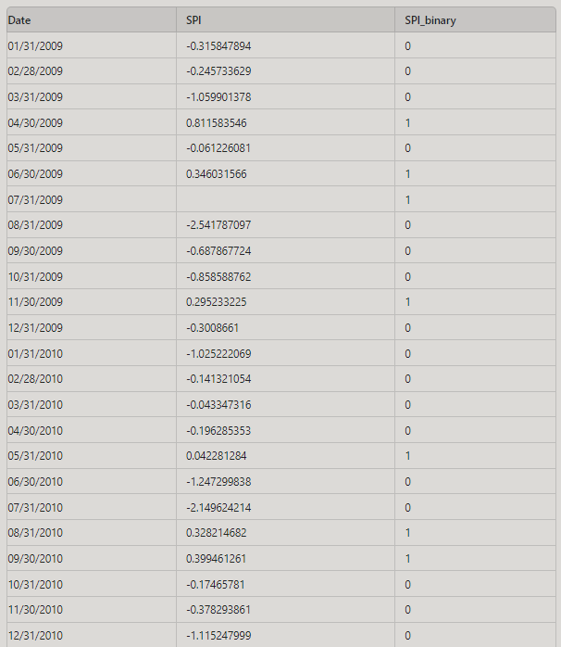

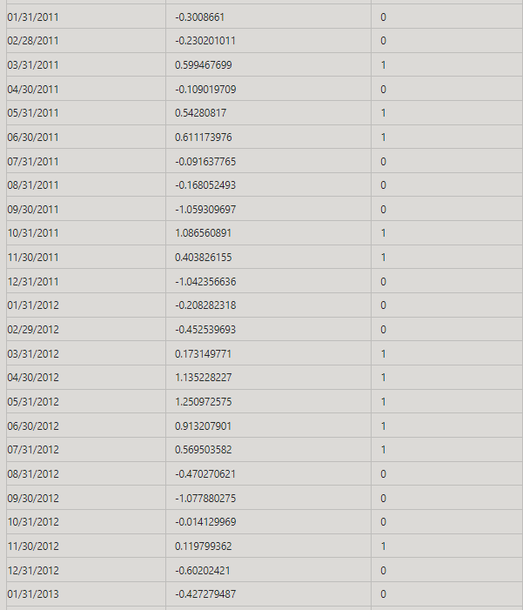
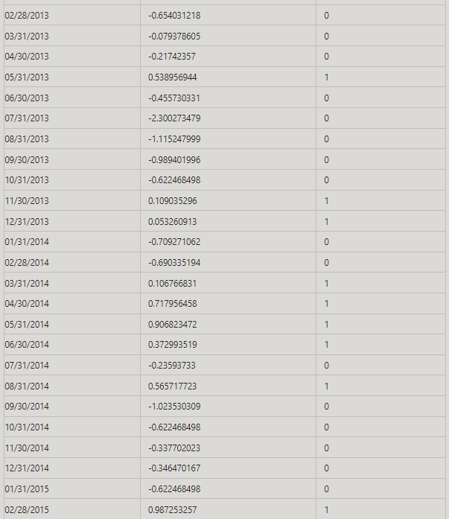
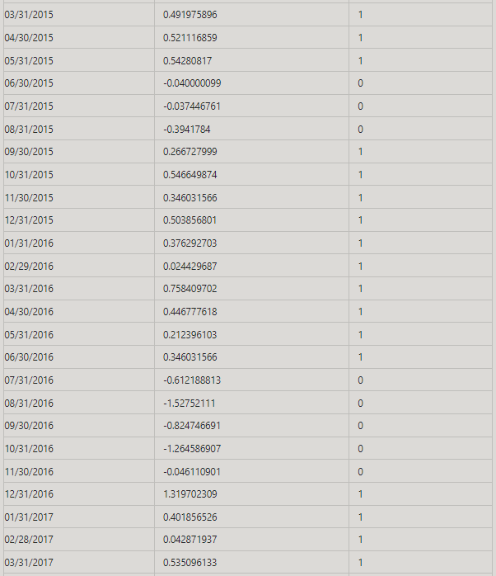
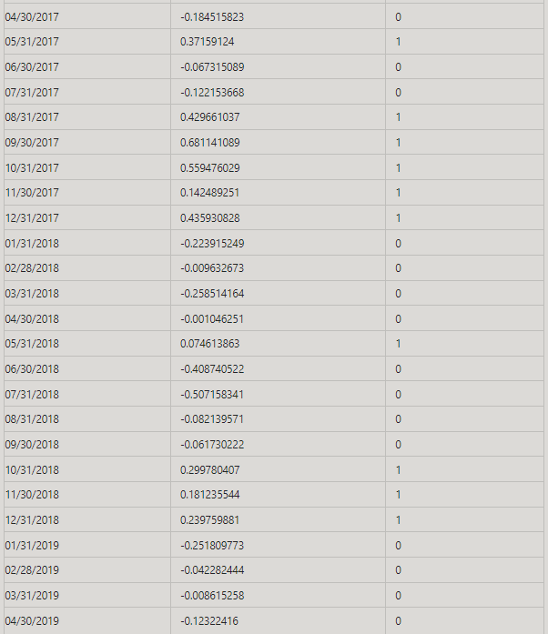
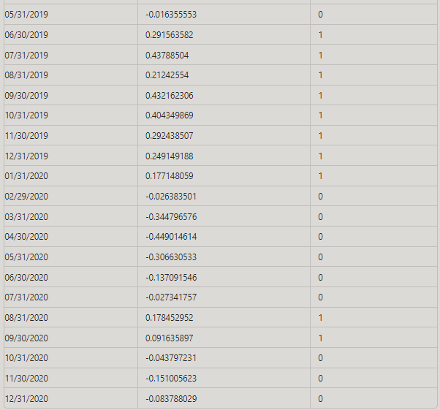

The binary SPI numbers for each year are saved in an Excel file as shown below:
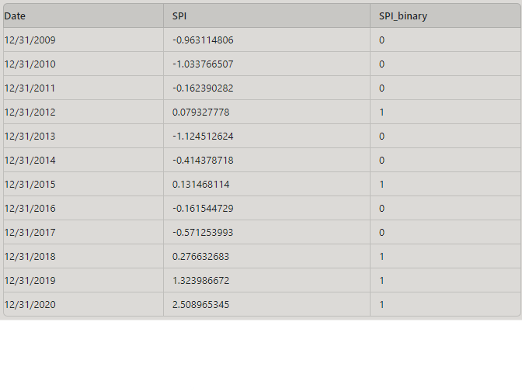
- Now that we have binary indicators (0 or 1) representing drought or wet conditions for each month and each year, we'll create a transition matrix. This matrix will illustrate the changes in conditions between months and years.

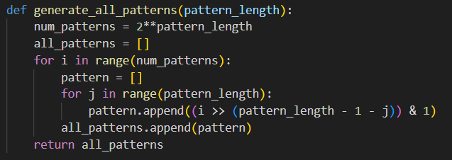
This function generates all possible binary patterns of a specified length.
num_patterns: Calculates the total number of binary patterns by raising 2 to the power of pattern_length.
Loop through num_patterns: For each integer from 0 to num_patterns - 1, it constructs a binary pattern.
Construct Pattern: Each pattern is created by extracting individual bits from the integer and arranging them in the correct order.
Return: The function returns a list of all binary patterns of the given length.
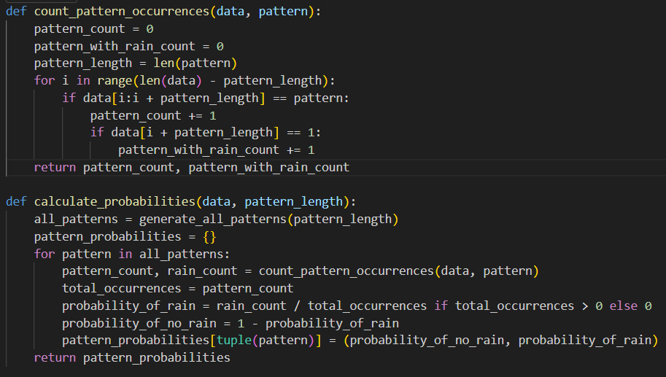
Function 1: count_pattern_occurrences
This function counts how often a specified binary pattern appears in a sequence and how many times it is followed by a 1.
- Inputs: data (a list of binary values) and pattern (a binary pattern).
- Process: It scans the data for occurrences of the pattern and checks if the value immediately following each occurrence is 1.
- Outputs: Returns two counts: the total number of occurrences of the pattern and the number of those occurrences followed by a 1.
Function 2: calculate_probabilities
This function calculates the probabilities of rain following all possible binary patterns of a given length.
- Inputs: data (a list of binary values) and pattern_length (length of the binary patterns).
- Process: Generates all binary patterns of the specified length, counts their occurrences and the number of times they are followed by a 1, then computes the probability of rain and no rain for each pattern.
- Outputs: Returns a dictionary where each key is a binary pattern (as a tuple) and the value is a tuple of probabilities: (probability of no rain, probability of rain).
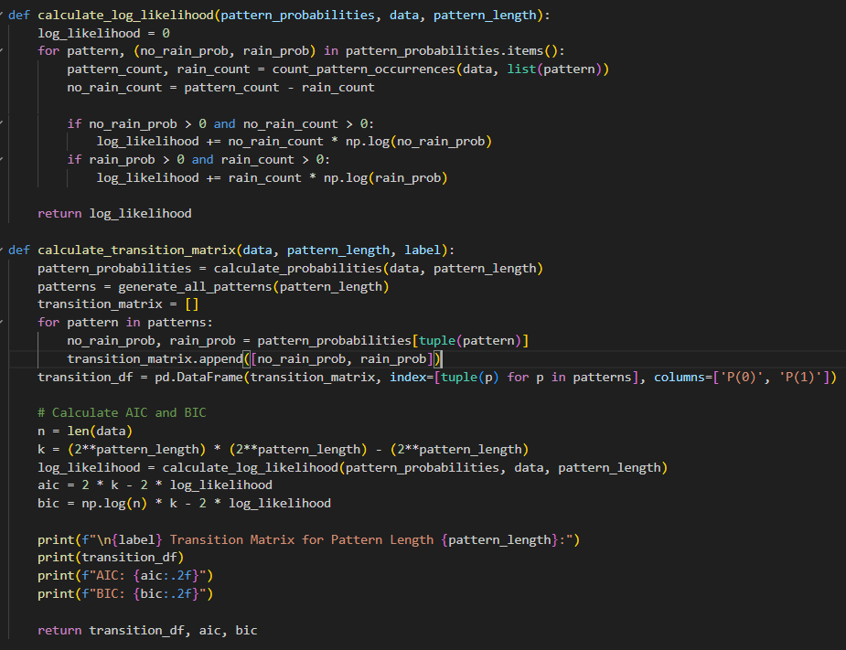
Function 1: calculate_log_likelihood
This function computes the log-likelihood of a model given binary pattern probabilities and data.
Inputs: pattern_probabilities (dictionary of probabilities for each pattern), data (binary sequence), and pattern_length (length of the patterns).
Process: For each pattern, it calculates how likely the observed counts of no rain and rain are, based on the model probabilities. It then sums the log-likelihood contributions for all patterns.
Output: Returns the total log-likelihood value.
Function 2: calculate_transition_matrix
This function creates a transition matrix for binary patterns, calculates model fit statistics (AIC and BIC), and prints the results.
Inputs: data (binary sequence), pattern_length (length of the patterns), and label (identifier for the output).

Process:
Computes the probabilities for all patterns.
Constructs a transition matrix where each row represents a pattern with its probabilities of no rain and rain.
Calculates AIC (Akaike Information Criterion) and BIC (Bayesian Information Criterion) to assess model fit.
Outputs: Prints the transition matrix, AIC, and BIC, and returns the transition matrix along with the AIC and BIC values.
Note: AIC and BIC are used to evaluate the goodness-of-fit for the model and compare different models based on their complexity and fit.
The transition probabilities are based on the state from the previous month:
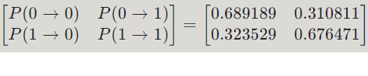
The transition probabilities are based on the state from the previous year:
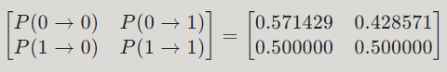

The transition probabilities are based on the state from two months prior:
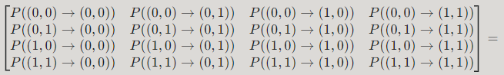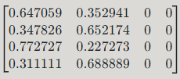

The transition probabilities are based on the state from two years prior:
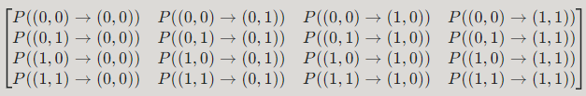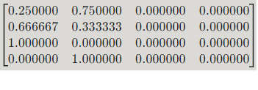
The transition probabilities are based on the state from three months prior:
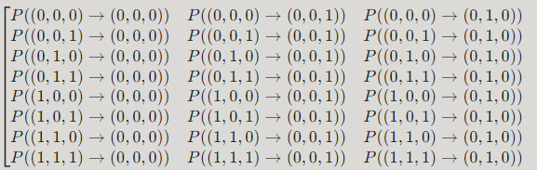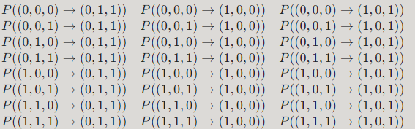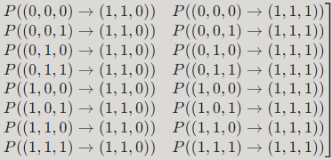
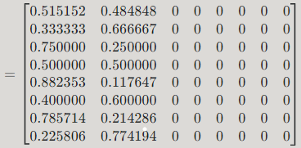
The transition probabilities are based on the state from three years prior:
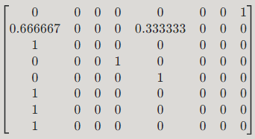
The transition probabilities are based on the state from four months prior:
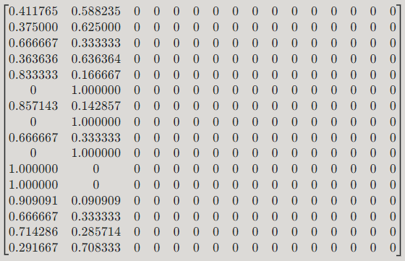

The transition probabilities are based on the state from four years prior:
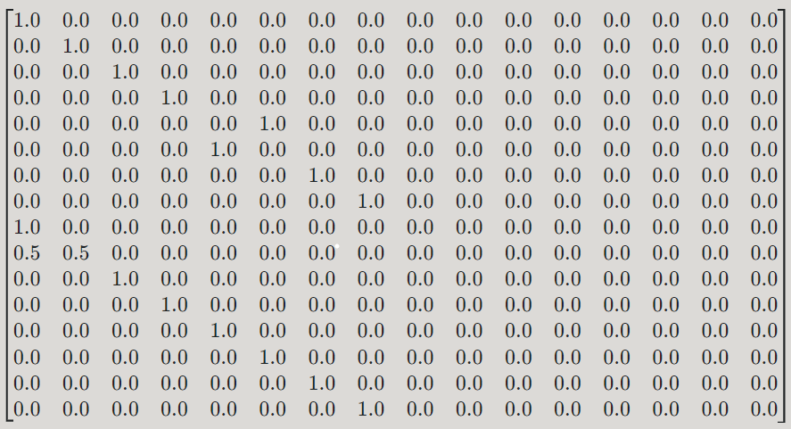
The transition probabilities are based on the state from five months prior:
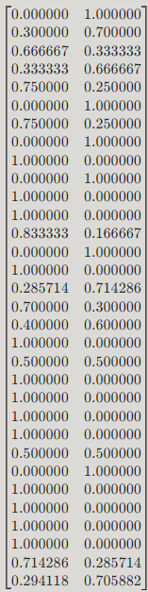
The remaining states have a transition probability of 0.

The transition probabilities are based on the state from five years prior:
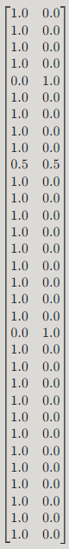
The remaining states have a transition probability of 0.
c)
To determine the best state space (SS) model fits for the dataset, the Akaike Information Criterion (AIC) and Bayesian Information Criterion (BIC) were utilized. Here's an explanation of how these criteria were applied and the results obtained:

Explanation of AIC and BIC:
Akaike Information Criterion (AIC) and Bayesian Information Criterion (BIC) are statistical measures used to compare different models based on their fit and complexity

AIC (Akaike Information Criterion):
AIC evaluates the quality of a model by balancing its goodness-of-fit with its complexity. Lower AIC values indicate a better model that is less likely to overfit the data.
Formula:
$AIC =$ $2k-2ln⁡(L)$
where:
$k$ = Number of parameters in the model
$L$ = Maximum value of the likelihood function for the model
BIC (Bayesian Information Criterion):
BIC also assesses model quality but includes a stronger penalty for model complexity, especially with large datasets. Lower BIC values suggest a better model with a balance between fit and simplicity.
Formula:
$$BIC=\log\left(n\right). k-2ln⁡(L)$$
where:
$n$ = Number of observations
$k$ = Number of parameters in the model
$L$ = Maximum value of the likelihood function for the model

Process of Applying AIC and BIC:
- Define State Space Models:
  - Various state space models were specified by adjusting parameters or model complexity.
- Fit Models and Calculate Criteria:
  - For each model, the transition matrix and pattern probabilities were calculated. The log-likelihood for each model was then computed.
  - The AIC and BIC values were derived using the formulas provided.
- Model Comparison:
  - Models were compared based on their AIC and BIC values. The model with the lowest AIC and BIC values was identified as the best fit.

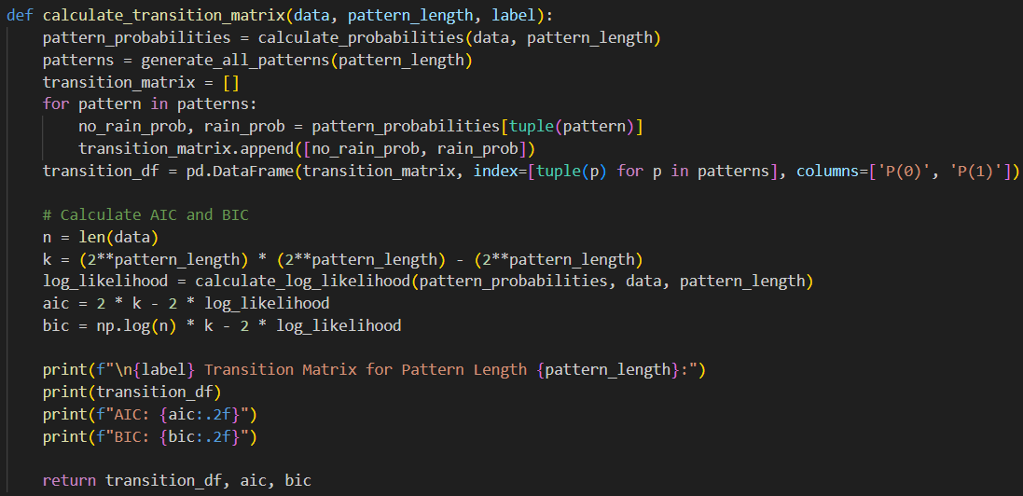
calculate_transition_matrix Function: Computes the transition matrix and evaluates the model using AIC and BIC.
For a model where the transition probabilities depend only on the previous month:
- AIC: 181.33
- BIC: 187.26
For a model where the transition probabilities depend only on the previous year:
- AIC: 19.11
- BIC: 20.08
For a model where the transition probabilities depend on the previous two months:
- AIC: 199.32
- BIC: 234.88
For a model where the transition probabilities depend on the previous two years:
- AIC: 32.32
- BIC: 38.14
For a model where the transition probabilities depend on the previous three months:
- AIC: 275.75
- BIC: 441.67

For a model where the transition probabilities depend on the previous three years:
- AIC: 115.82
- BIC: 142.97
For a model where the transition probabilities depend on the previous four months:
- AIC: 624.38
- BIC: 1335.46
For a model where the transition probabilities depend on the previous four years:
- AIC: 482.77
- BIC: 599.15
For a model where the transition probabilities depend on the previous five months:
- AIC: 2102.65
- BIC: 5041.79
For a model where the transition probabilities depend on the previous five years:
- AIC: 1986.77
- BIC: 2467.80

Analysis
- Lowest AIC: The model where transition probabilities depend on the previous year (AIC: 19.11) has the lowest AIC, suggesting it fits the data best among the considered models when accounting for complexity.
- Lowest BIC: Similarly, the model where transition probabilities depend on the previous year (BIC: 20.08) has the lowest BIC, indicating it is the best model when penalizing for complexity more strictly.

Conclusion
The model where transition probabilities depend only on the previous year has the best fit based on both AIC and BIC. This model strikes a good balance between fit and complexity, making it the most suitable choice among the models considered.
- Best Model: Transition probabilities depend on the previous year.

Part 2:
In this part of the modeling, we are not using SPI; instead, we are modeling based on the mean rainfall for each month and each year.

First, we calculate the average rainfall for each month and each year and save it to an Excel file. Then, we categorize each average value using the function def categorize_mean_rainfall(mean_rainfall): and save the results to the Excel file as follows:
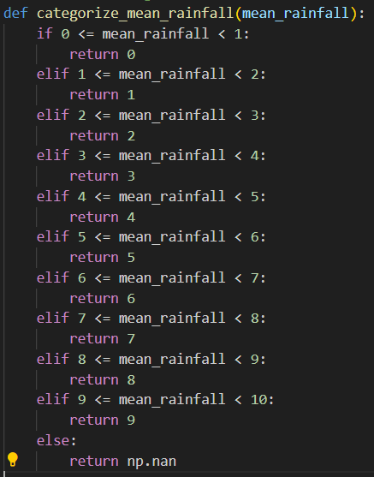

The table below is for the model for each month:

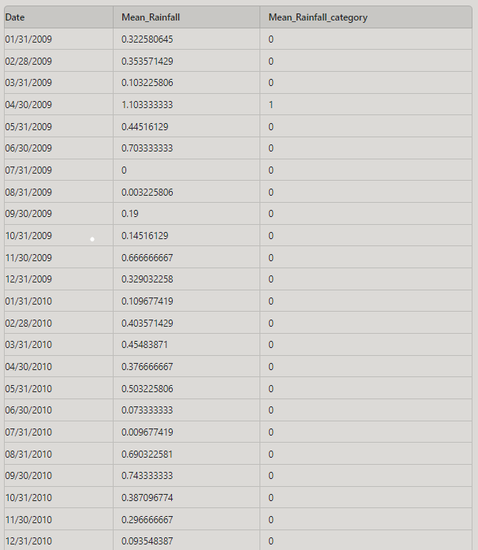
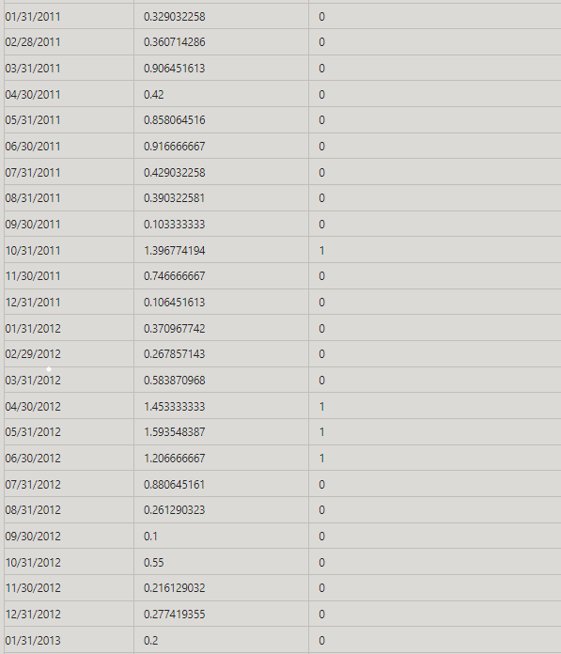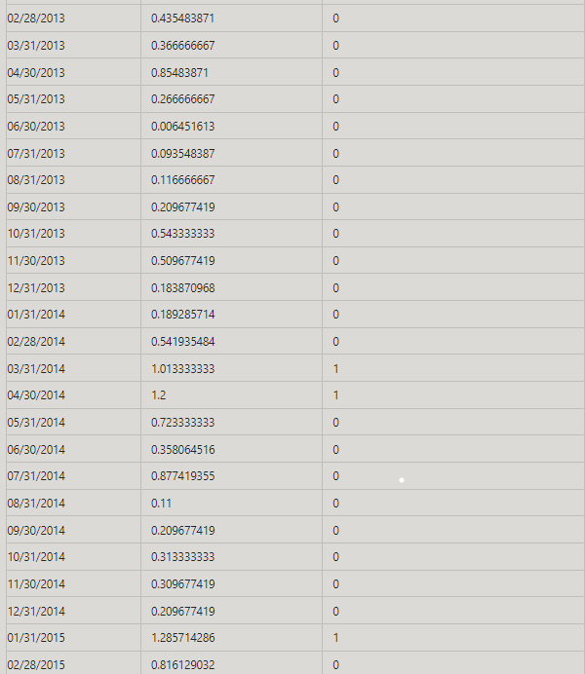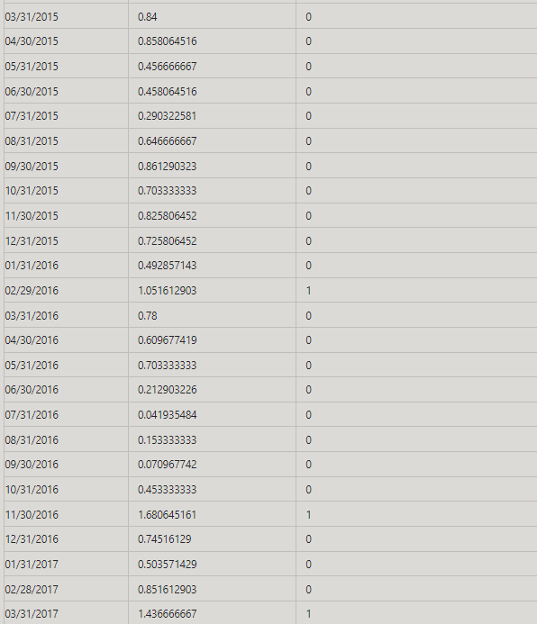
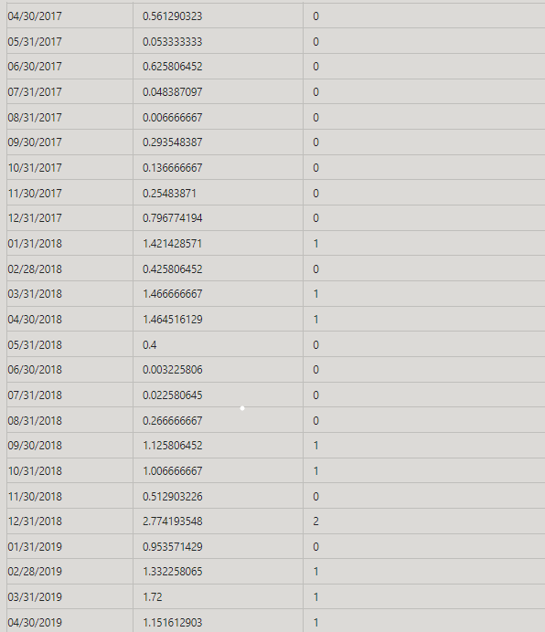
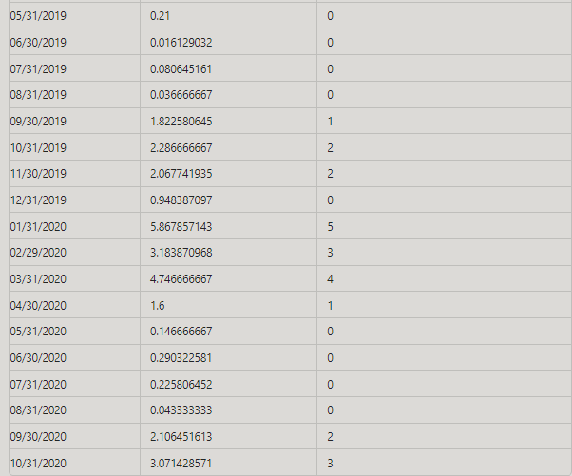

The table below is for the model for each year:

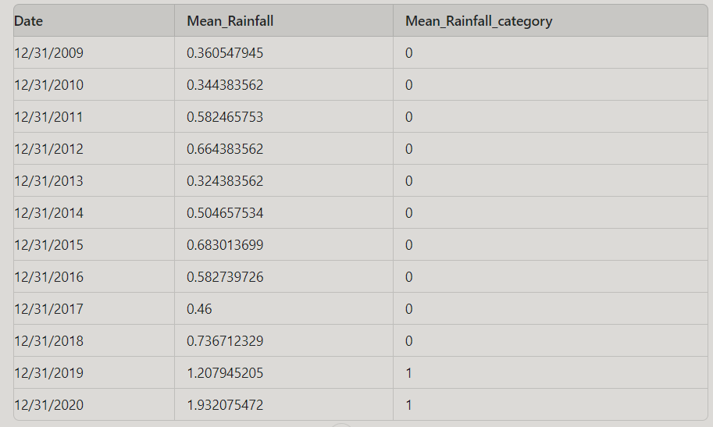

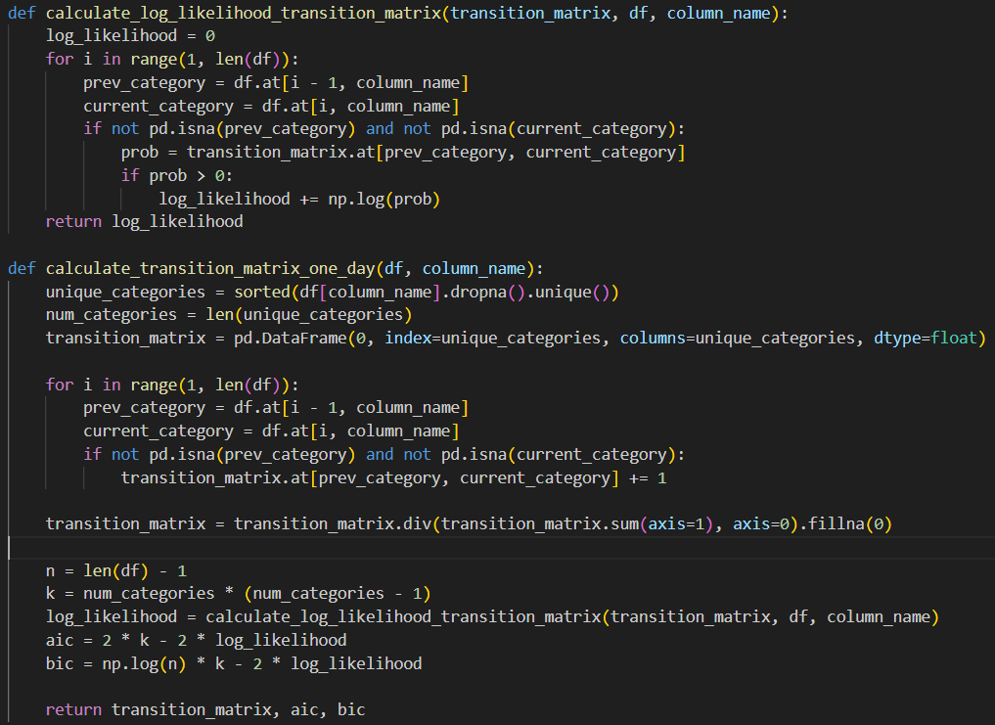
These two functions calculate the transition matrix for a categorical column, considering transitions from one month to the next. They also compute the Akaike Information Criterion (AIC) and Bayesian Information Criterion (BIC) for model evaluation.

Function 1: calculate_log_likelihood_transition_matrix
- Purpose: Computes the log-likelihood of the observed transitions based on the transition matrix.
- Steps:
  - Loop through the DataFrame from the second row.
  - For each transition, get the probability from the matrix.
  - Add the log of this probability to the log-likelihood if the probability is greater than zero.

Function 2: calculate_transition_matrix_one_day
- Purpose: Calculates the transition matrix and evaluates it using AIC and BIC.
- Steps:
  - Compute Transition Matrix: Count transitions from one day to the next and normalize to probabilities.
  - Calculate AIC and BIC:
    - $AIC: 2 * k - 2 * log_likelihood$
    - $BIC: np.log(n) * k - 2 * log_likelihood$
  - Return: Transition matrix, AIC, and BIC.

The transition probabilities, AIC and BIC are based on the state from the previous month:
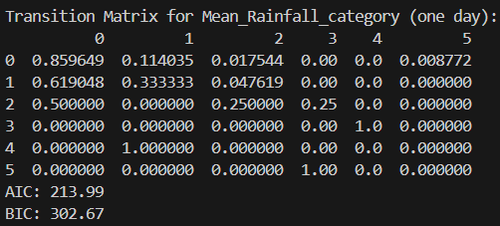
The transition probabilities, AIC, and BIC are based on the state from two months prior:
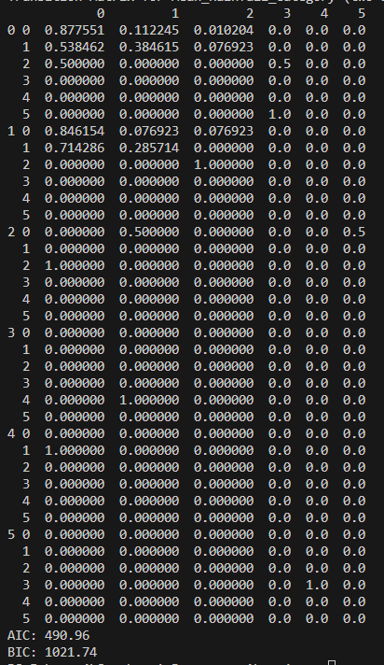

We will continue in the same manner for other cases.

Part 3: Repeat Part, but relax assume (i)
We aim to estimate the parameters of a Hidden Markov Model (HMM) using observed weather data and compare the hidden states generated by the model with actual rain data. Our observed variables include humidity, cloud cover, temperature, pressure, wind, and general weather conditions. The hidden states we are interested in are "rainy" and "sunny".

2. HMM and Its Capabilities
In HMMs, three primary questions are addressed:
- Given the model parameters and observed data, estimate the optimal sequence of hidden states.
- Given the model parameters and observed data, calculate the model likelihood.
- Given just the observed data, estimate the model parameters.
In our case, we will focus on the third question: estimating the model parameters given just the observed data.

3. Data Preparation

3.1 Compute Monthly Averages
- Observation Data: For each observation variable (humidity, cloud cover, temperature, pressure, wind, and weather), calculate the mean for each month. This will give us a vector of mean values for each month.
- Rain Data: Similarly, compute the mean rain value for each month.

3.2 Organize Data
- Create a matrix where each row represents a month and each column contains the mean values of the corresponding observation variables. The resulting matrix will have months as rows and observation types as columns.

4. Model Assumptions
- We assume that the observation data follows a normal distribution.

5. Standardize the Data
- Standardize the observation data to ensure each feature has a mean of zero and a standard deviation of one. This normalization step is crucial for improving the performance of the HMM.

6. Fit the HMM
- Calculate Statistics: Compute the mean and covariance matrix of the standardized data.
- Model Training: Use the hmmlearn library in Python to fit the HMM to the standardized data. This involves:
  - Initializing the HMM with the calculated statistics.
  - Training the HMM on the observation data to estimate the model parameters.

7. Convert Rain Data to States
- Define a threshold to classify the mean rain data into two states: "sunny" or "rainy".
  - Threshold Calculation: Use the median of the monthly mean rain values as the threshold.
  - State Assignment: Classify months with mean rain values above the threshold as "rainy" and those below as "sunny".

8. Compare Hidden States with Rain Data
- After fitting the HMM, most likely sequence of hidden states.
- Compare these hidden states with the classified rain states ("sunny" or "rainy") to evaluate the model’s performance.

